- Open the VBA Editor in Excel and write a simple macro in Module1 that displays a message box saying 'Welcome to VBA Programming!' when run.
ANSWERS:
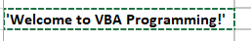
- Declare three variables in VBA: userName as String, orderCount as Integer, and isPremiumUser as Boolean. Assign sample values and use MsgBox to display all three values in a single message.
ANSWERS:
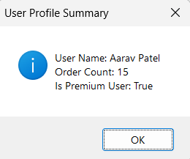

- Write a VBA macro that checks if a given cell (A1) in the active worksheet contains a value greater than 100. If true, color the cell green; if false, color it red.

Hint: Use If...Then and the Interior.Color property.
ANSWERS:

- Create a VBA subroutine that loops through cells A1 to A10 in the active worksheet and sets each cell's value to its row number using a For loop.
ANSWERS:
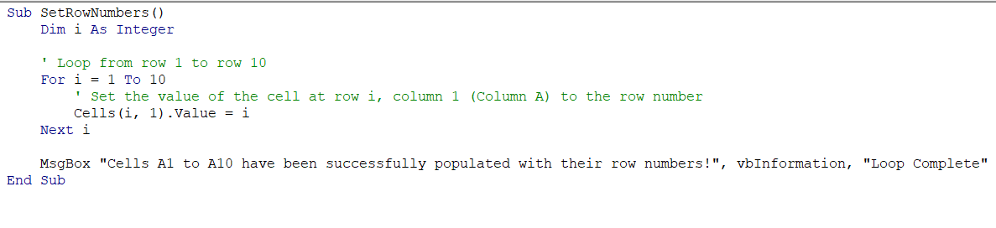

- Write a VBA macro that goes through all worksheets in the current workbook and sets the font of all cells in range A1:D1 to bold and font size 14.
Hint: Use a For Each loop with Worksheets and the Range property.
ANSWERS:

